MEDIA RELEASE

NEX Technology enabling tubes for life

Micro-X is defining the future of x-ray imaging.

Micro-X is the first company in the world to design and manufacture a mobile X-ray machine using NEX Technology. Their patented NEX Technology uses carbon nanotubes to create a more stable, yet smaller and lighter X-ray tube that now comes with a ‘Tubes for Life’ warranty.

The reliability of NEX Technology means Micro-X customers will enjoy the benefits from cutting edge technology with the assurance of long-lasting tube performance.

The ‘Tubes for Life’ warranty is a non-transferrable warranty designed to cover the X-ray tube installed in each Micro-X mobile X-ray machine.

NEX Technology is a simple, non-glass-based electronic X-ray tube and enables Micro-X to produce a more stable, yet smaller and lighter X-ray tube which in turn reduces the weight, and size, of their mobile X-ray machines.

The first generation of these mobile X-rays machines are already used in over 31 countries worldwide.

For hospitals the “Tubes for Life” warranty means peace of mind when choosing their next mobile X-ray machine knowing they can benefit from improved system availability and up time.

At the 2021 RSNA Annual Meeting, Micro-X is presenting their latest models of their revolutionary mobile X-ray machine:
- PICO offers full medical performance suitable for use in all areas of a hospital including more specialized and demanding environments such as an Emergency Department or Operating Theatre
- NEO is a modified PICO for use in neonatal and pediatric applications.

Micro-X is also offering their Rover mobile X-ray machine at the 2021 RSNA Annual Meeting, all with NEX Technology inside.

Charlie Hicks, General Manager Mobile DR says, “Micro-X is defining the future of X-ray imaging, similar to how LED’s have replaced traditional glass filament light bulbs, I truly believe that NEX technology is the future of X-ray imaging. We are so confident in the reliability and performance of this new tube technology that we are willing to back it with our incredible Tubes for Life warranty.”

Meet PICO, NEO and Charlie at the Micro-X stand, South Hall, stand #4517 during the RSNA Annual Meeting or go to www.micro-x.com/rsna2021 for more information.

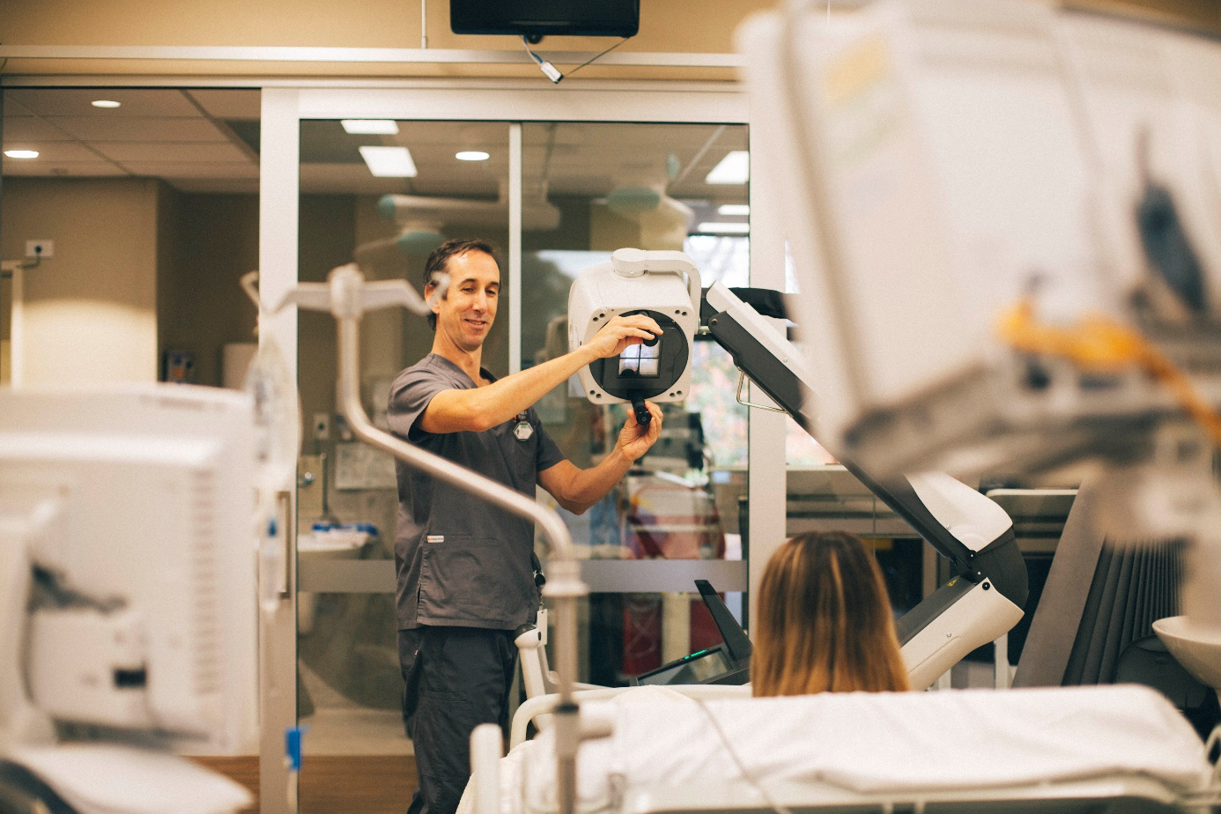

Image supplied – Micro-X mobile x-ray system taking chest x-ray in ICU room.

