COMPANY PROFILE

Smaller, lighter, more reliable

Micro-X is defining the future of x-ray imaging.

Micro-X is the first company in the world to design and manufacture a mobile X-ray machine using NEX Technology. Their patented NEX Technology uses carbon nanotubes to create a more stable, yet smaller and lighter X-ray tube that now comes with a ‘Tubes for Life’ warranty.

NEX Technology enables Micro-X to reduce the weight, and size, of their mobile X-ray systems. Weighing around 200 pounds these new mobile X-ray machines have no need for motors due to its featherlight drive design.

The first generation of these mobile X-rays machines are already used in over 31 countries worldwide.

For hospitals this means an X-ray machine that can be more easily maneuvered through hospital corridors to a patient’s bedside, and more easily and safely positioned by radiographers, improving working conditions and workflow.

At the 2021 RSNA Annual Meeting, Micro-X is presenting their latest models of their revolutionary mobile X-ray systems:
- PICO offers full medical performance suitable for use in all areas of a hospital including more specialized and demanding environments such as an Emergency Department or Operating Theatre
- NEO is a modified PICO for use in neonatal and pediatric applications.

PICO and NEO models are currently pending marketing authorization applications in USA.

Micro-X is also developing new applications for its NEX Technology including a CT brain scanner that can fit in ambulances or be deployed in other Point-of-Care environments.

This innovative design has an arc of multiple static X-ray emitters that replace the moving head of conventional CT scanners.

This technology will allow paramedics to diagnose and start treatment for stroke patients on the way to hospital during the “golden hour” thus increasing the chance of survival and avoiding long-term brain damage.

This cost-effective CT Brain Scanner has the potential to replace Mobile Stroke Units which require fully-equipped, custom-built specialized vehicles and can cost more than $1 million each.

Charlie Hicks, General Manager Mobile DR says, “I have witnessed firsthand the capabilities of this technology and truly believe that it is the future of x-ray imaging. The inherent reliability, smaller size and weight of what is essentially an electronic tube will make this the ubiquitous replacement for traditional and outdated glass-based x-ray tube solutions.”

Beyond the hospital
The US Homeland Security Department has also seen the potential for NEX Technology and believes it can be used to transform passenger screening at airports. They are investing in the development of a self-service security screening station for airport passengers.

This will combine the traditional, sequential airport checkpoint processes into a single consolidated module.

“It is a tribute to Micro-X’s customer-centric design philosophy to be selected for this major new systems design and integration project,” says Micro-X’s Seattle-based General Manager, Dr Brian Gonzales.

Meet PICO, NEO, Hicks and Gonzales at the Micro-X booth, South Hall, stand #4517 during the RSNA Annual Meeting or go to www.micro-x.com/rsna2021 for more information.

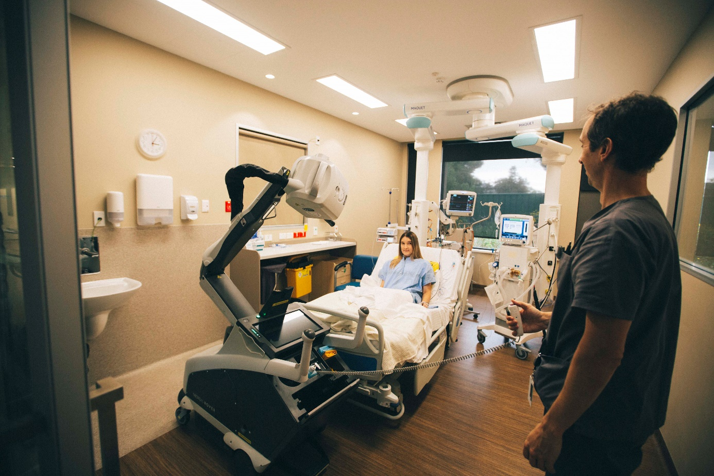

Image supplied – Micro-X mobile x-ray system taking chest x-ray in ICU room.

